SCD-LAB-12
K22-5195
1)
package org.k224818.scdlab12.config;
import org.springframework.context.annotation.Bean;
import org.springframework.context.annotation.Configuration;
import org.springframework.security.config.annotation.web.builders.HttpSecurity;
import org.springframework.security.config.annotation.web.configuration.EnableWebSecurity;
import org.springframework.security.config.annotation.web.configuration.WebSecurityCustomizer;
import org.springframework.security.core.userdetails.User;
import org.springframework.security.core.userdetails.UserDetails;
import org.springframework.security.crypto.bcrypt.BCryptPasswordEncoder;
import org.springframework.security.crypto.password.PasswordEncoder;
import org.springframework.security.provisioning.InMemoryUserDetailsManager;
import org.springframework.security.web.SecurityFilterChain;
@Configuration
@EnableWebSecurity
public class SecurityConfig {
@Bean
public PasswordEncoder passwordEncoder() {
return new BCryptPasswordEncoder();
}
@Bean
public SecurityFilterChain securityFilterChain(HttpSecurity http) throws Exception {
http
.authorizeHttpRequests((authz) -> authz
.requestMatchers("/login", "/signup", "/public/**").permitAll() // Allow login/signup/public to everyone
.requestMatchers("/admin/**").hasRole("ADMIN") // Only allow Admin to access /admin/**
.requestMatchers("/superadmin/**").hasRole("SUPERADMIN") // Only allow Super Admin to access /superadmin/**
.requestMatchers("/user/**").hasRole("USER") // Only allow USER to access /user/**
.anyRequest().authenticated() // Other pages require authentication
)
.formLogin(form -> form.loginPage("/login").permitAll()) // Custom login page, open for all
.logout(logout -> logout.permitAll()); // Allow logout for all
return http.build();
}
@Bean
public WebSecurityCustomizer webSecurityCustomizer() {
return (web) -> web.ignoring().requestMatchers("/resources/**", "/static/**");
}
@Bean
public InMemoryUserDetailsManager userDetailsService() {
UserDetails user = User.builder()
.username("user")
.password(passwordEncoder().encode("password")) // Encode password
.roles("USER")
.build();
UserDetails admin = User.builder()
.username("admin")
.password(passwordEncoder().encode("adminpassword")) // Encode password
.roles("ADMIN")
.build();
UserDetails superAdmin = User.builder()
.username("superadmin")
.password(passwordEncoder().encode("superadminpassword")) // Encode password
.roles("SUPERADMIN")
.build();
return new InMemoryUserDetailsManager(user, admin, superAdmin);
}
}
package org.k224818.scdlab12.controllers;
import org.k224818.scdlab12.models.User;
import org.k224818.scdlab12.service.UserService;
import org.springframework.security.access.annotation.Secured;
import org.springframework.security.core.context.SecurityContextHolder;
import org.springframework.security.crypto.password.PasswordEncoder;
import org.springframework.stereotype.Controller;
import org.springframework.ui.Model;
import org.springframework.web.bind.annotation.*;
import java.util.Set;
@Controller
public class UserController {
private final UserService userService;
private final PasswordEncoder passwordEncoder;
public UserController(UserService userService, PasswordEncoder passwordEncoder) {
this.userService = userService;
this.passwordEncoder = passwordEncoder;
}
@GetMapping("/login")
public String loginPage() {
return "login";
}
@GetMapping("/signup")
public String signupPage() {
return "signup";
}
@PostMapping("/signup")
public String register(@RequestParam String username,
@RequestParam String password) {
userService.registerUser(username, password, Set.of("USER"));
return "redirect:/login";
}
// Admin Dashboard
@Secured("ROLE_ADMIN")
@GetMapping("/admin/dashboard")
public String adminDashboard(Model model) {
model.addAttribute("users", userService.findAllUsers());
return "admin-dashboard";
}
@Secured("ROLE_SUPERADMIN")
@GetMapping("/superadmin/dashboard")
public String superAdminDashboard(Model model) {
model.addAttribute("users", userService.findAllUsers());
return "superadmin-dashboard";
}
@Secured("ROLE_SUPERADMIN")
@PostMapping("/superadmin/manage")
public String manageRoles(@RequestParam String username, @RequestParam Set<String> roles) {
userService.updateUserRoles(username, roles);
return "redirect:/superadmin/dashboard";
}
@GetMapping("/user/profile")
public String userProfile(Model model) {
String username = SecurityContextHolder.getContext().getAuthentication().getName();
User user = userService.findByUsername(username);
model.addAttribute("user", user);
return "user-profile";
}
}
package org.k224818.scdlab12.models;
import jakarta.persistence.*;
import java.util.Set;
@Entity
public class User {
@Id
@GeneratedValue(strategy = GenerationType.IDENTITY)
private Long id;
private String username;
private String password;
@ElementCollection(fetch = FetchType.EAGER)
private Set<String> roles;
public User() {
}
public Long getId() {
return id;
}
public void setId(Long id) {
this.id = id;
}
public String getUsername() {
return username;
}
public void setUsername(String username) {
this.username = username;
}
public String getPassword() {
return password;
}
public void setPassword(String password) {
this.password = password;
}
public Set<String> getRoles() {
return roles;
}
public User(Long id, String username, String password, Set<String> roles) {
this.id = id;
this.username = username;
this.password = password;
this.roles = roles;
}
public void setRoles(Set<String> roles) {
this.roles = roles;
}
}
package org.k224818.scdlab12.repo;
import org.k224818.scdlab12.models.User;
import org.springframework.data.jpa.repository.JpaRepository;
public interface UserRepository extends JpaRepository<User, Long> {
User findByUsername(String username);
}
package org.k224818.scdlab12.service;
import org.k224818.scdlab12.models.User;
import org.k224818.scdlab12.repo.UserRepository;
import org.springframework.security.crypto.password.PasswordEncoder;
import org.springframework.stereotype.Service;
import org.springframework.transaction.annotation.Transactional;
import java.util.List;
import java.util.Set;
@Service
public class UserService {
private final UserRepository userRepository;
private final PasswordEncoder passwordEncoder;
public UserService(UserRepository userRepository, PasswordEncoder passwordEncoder) {
this.userRepository = userRepository;
this.passwordEncoder = passwordEncoder;
}
@Transactional
public User registerUser(String username, String password, Set<String> roles) {
User user = new User();
user.setUsername(username);
user.setPassword(passwordEncoder.encode(password));
user.setRoles(roles);
return userRepository.save(user);
}
public User findByUsername(String username) {
return userRepository.findByUsername(username);
}
@Transactional
public User updateUserRoles(String username, Set<String> roles) {
User user = findByUsername(username);
if (user != null) {
user.setRoles(roles);
return userRepository.save(user);
}
return null;
}
public List<User> findAllUsers() {
return userRepository.findAll();
}
}
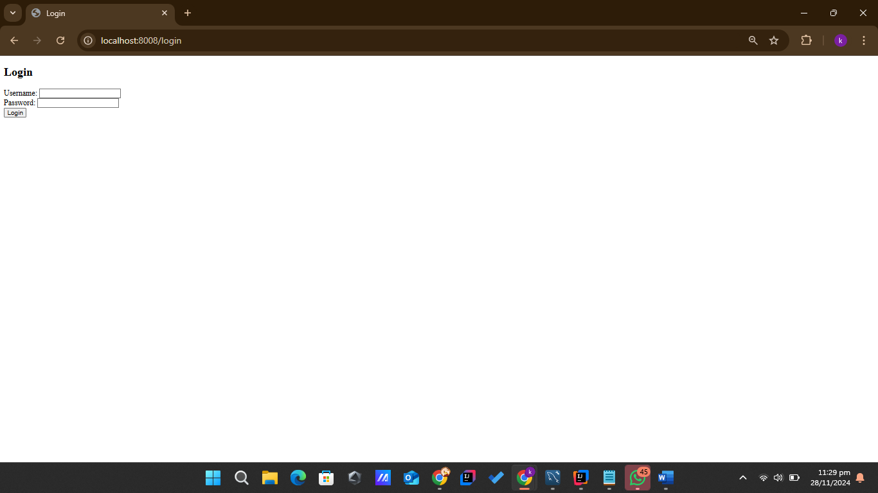
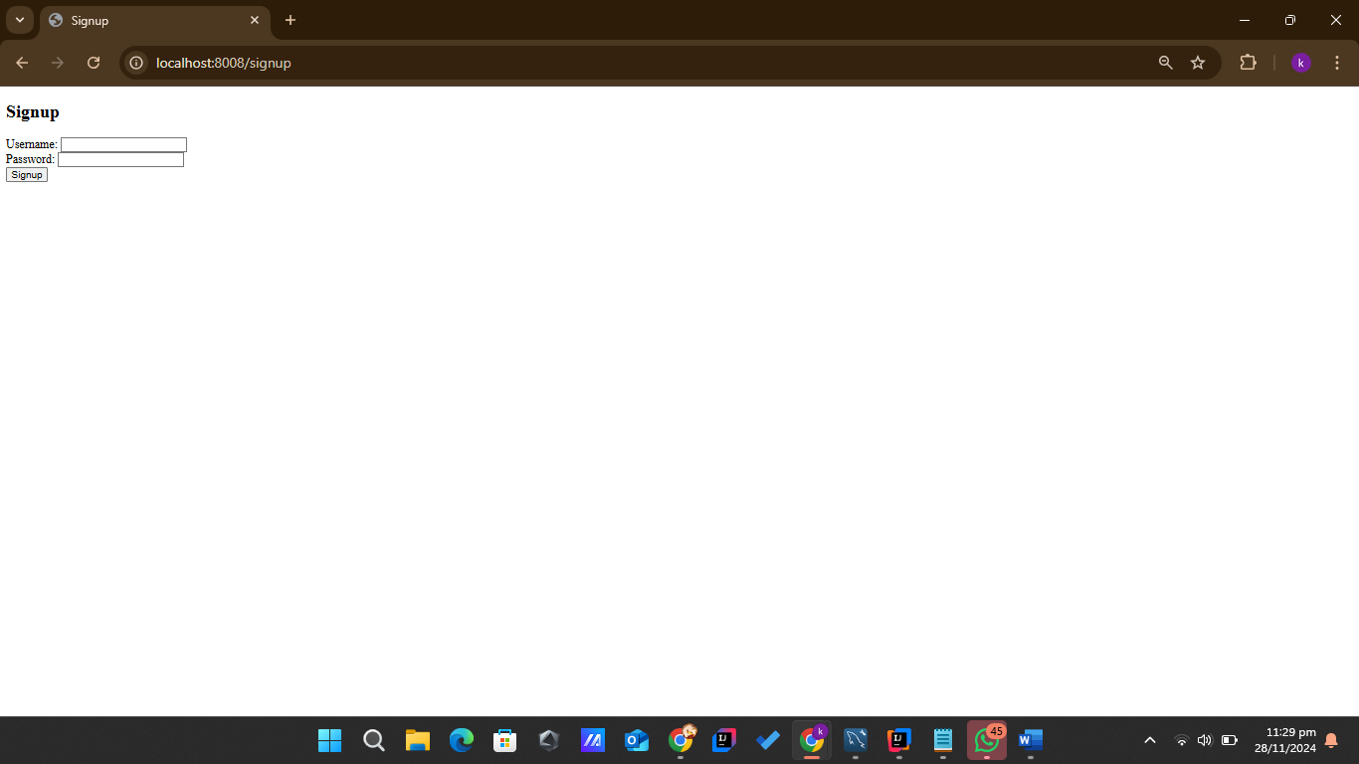

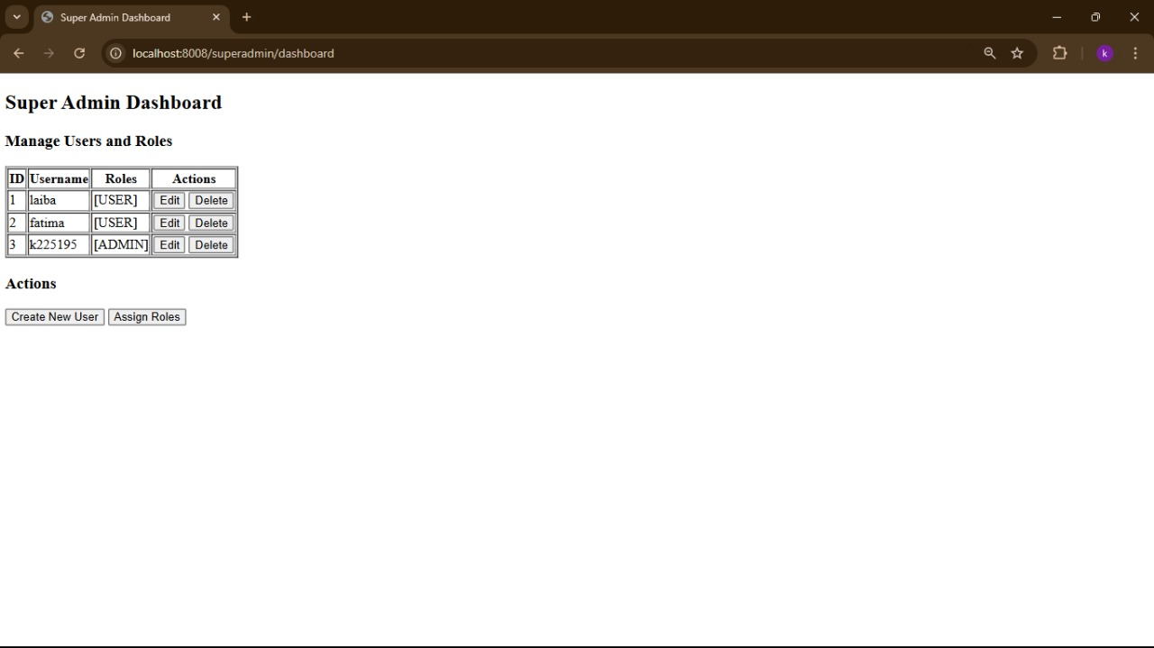
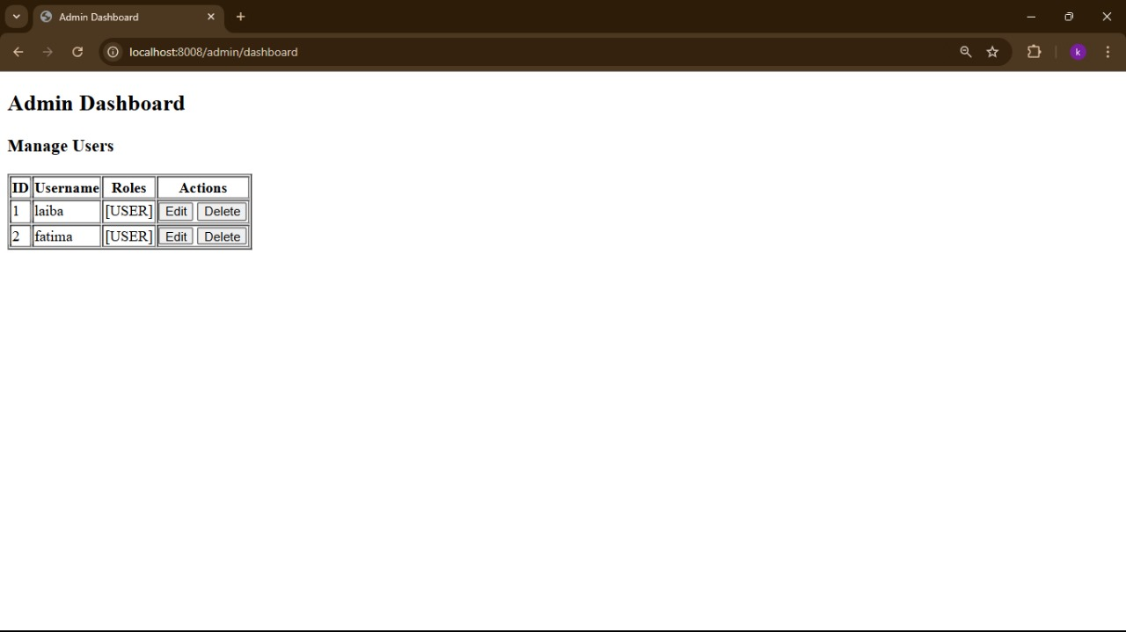

2)

package org.k224818.scdlab12.models;
import jakarta.persistence.*;
@Entity
public class Category {
@Id
@GeneratedValue(strategy = GenerationType.IDENTITY)
private Long categoryId;
@Column(nullable = false, unique = true)
private String name;
}

package org.k224818.scdlab12.models;
import jakarta.persistence.*;
@Entity
public class Item {
@Id
@GeneratedValue(strategy = GenerationType.IDENTITY)
private Long itemId;
@Column(nullable = false)
private String name;
@ManyToOne
@JoinColumn(name = "category_id", nullable = false)
private Category category;
@Column(nullable = false)
private Double price;
@Column(nullable = false)
private Integer stock;
}

package org.k224818.scdlab12.repo;
import org.k224818.scdlab12.models.Category;
import org.springframework.data.jpa.repository.JpaRepository;
public interface CategoryRepository extends JpaRepository<Category, Long> {
}

package org.k224818.scdlab12.repo;
import org.k224818.scdlab12.models.Item;
import org.springframework.data.jpa.repository.JpaRepository;
public interface ItemRepository extends JpaRepository<Item, Long> {
}

package org.k224818.scdlab12.service;
import org.k224818.scdlab12.models.Category;
import org.k224818.scdlab12.repo.CategoryRepository;
import org.springframework.beans.factory.annotation.Autowired;
import org.springframework.stereotype.Service;
import java.util.List;
import java.util.Optional;
@Service
public class CategoryService {
@Autowired
private CategoryRepository categoryRepository;
public List<Category> getAllCategories() {
return categoryRepository.findAll();
}
public Category addCategory(Category category) {
return categoryRepository.save(category);
}
public Optional<Category> getCategoryById(Long id) {
return categoryRepository.findById(id);
}
public void deleteCategory(Long id) {
categoryRepository.deleteById(id);
}
}

package org.k224818.scdlab12.repo;
import org.k224818.scdlab12.models.Item;
import org.springframework.beans.factory.annotation.Autowired;
import org.springframework.stereotype.Service;
import java.util.List;
import java.util.Optional;
@Service
public class ItemService {
@Autowired
private ItemRepository itemRepository;
public List<Item> getAllItems() {
return itemRepository.findAll();
}
public Item addItem(Item item) {
return itemRepository.save(item);
}
public Optional<Item> getItemById(Long id) {
return itemRepository.findById(id);
}
public void deleteItem(Long id) {
itemRepository.deleteById(id);
}
}

package org.k224818.scdlab12.controllers;
import org.k224818.scdlab12.models.Category;
import org.k224818.scdlab12.service.CategoryService;
import org.springframework.beans.factory.annotation.Autowired;
import org.springframework.web.bind.annotation.*;
import java.util.List;
@RestController
@RequestMapping("/categories")
public class CategoryController {
@Autowired
private CategoryService categoryService;
@GetMapping
public List<Category> getAllCategories() {
return categoryService.getAllCategories();
}
@PostMapping
public Category addCategory(@RequestBody Category category) {
return categoryService.addCategory(category);
}
@GetMapping("/{id}")
public Category getCategoryById(@PathVariable Long id) {
return categoryService.getCategoryById(id).orElseThrow(() -> new RuntimeException("Category not found"));
}
@DeleteMapping("/{id}")
public void deleteCategory(@PathVariable Long id) {
categoryService.deleteCategory(id);
}
}
package com.example.restaurant.controller;
import com.example.restaurant.model.Item;
import com.example.restaurant.service.ItemService;
import org.springframework.beans.factory.annotation.Autowired;
import org.springframework.web.bind.annotation.*;
import java.util.List;
@RestController
@RequestMapping("/items")
public class ItemController {
@Autowired
private ItemService itemService;
@GetMapping
public List<Item> getAllItems() {
return itemService.getAllItems();
}
@PostMapping
public Item addItem(@RequestBody Item item) {
return itemService.addItem(item);
}
@GetMapping("/{id}")
public Item getItemById(@PathVariable Long id) {
return itemService.getItemById(id).orElseThrow(() -> new RuntimeException("Item not found"));
}
@DeleteMapping("/{id}")
public void deleteItem(@PathVariable Long id) {
itemService.deleteItem(id);
}
}
<form action="/categories" method="post">
<input type="text" name="name" placeholder="Category Name" required>
<button type="submit">Add Category</button>
</form>
<ul>
<li th:each="category : ${categories}">
<span th:text="${category.name}"></span>
<a th:href="@{/categories/{id}(id=${category.categoryId})}">Delete</a>
</li>
</ul>

<form action="/items" method="post">
<input type="text" name="name" placeholder="Item Name" required>
<input type="number" name="price" placeholder="Price" required>
<input type="number" name="stock" placeholder="Stock" required>
<select name="categoryId">
<option th:each="category : ${categories}" th:value="${category.categoryId}" th:text="${category.name}"></option>
</select>
<button type="submit">Add Item</button>
</form>
<ul>
<li th:each="item : ${items}">
<span th:text="${item.name}"></span> -
<span th:text="${item.category.name}"></span> -
<span th:text="${item.price}"></span>
<a th:href="@{/items/{id}(id=${item.itemId})}">Delete</a>
</li>
</ul>

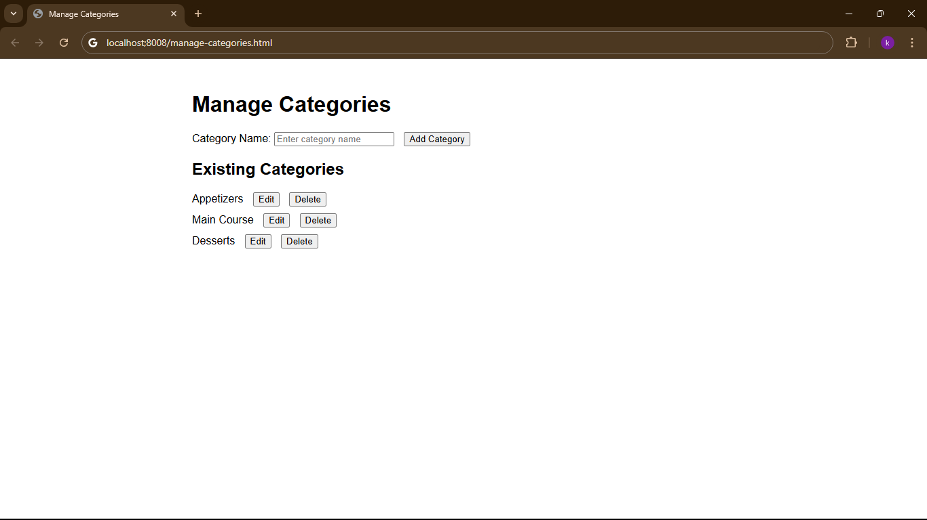
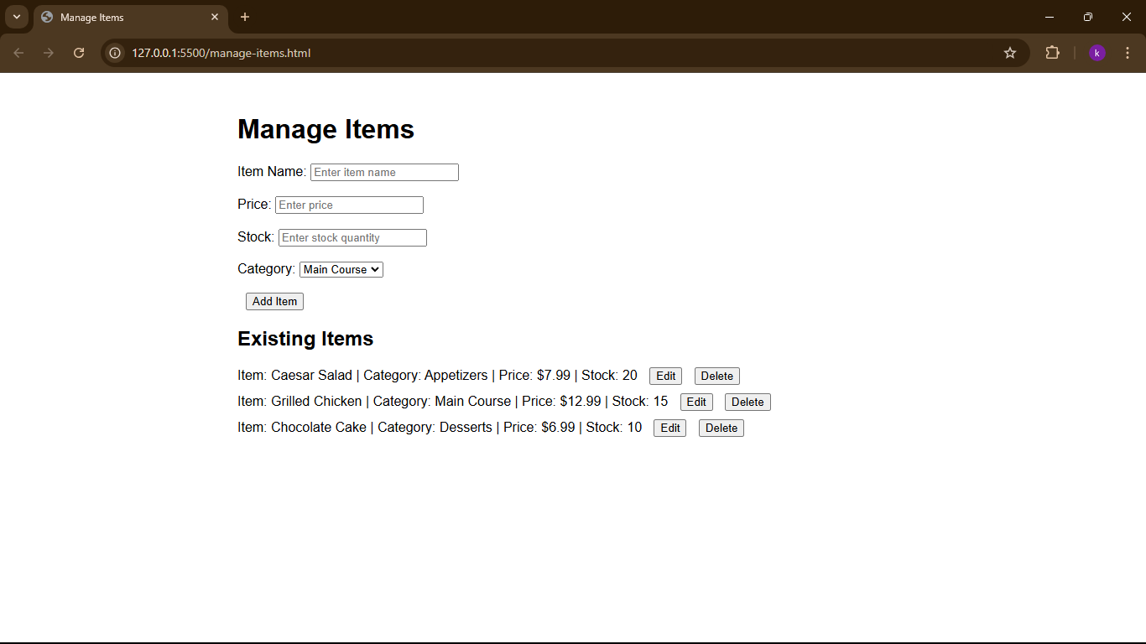

3)
}
package org.k224818.scdlab12.config;
import org.springframework.beans.factory.annotation.Autowired;
import org.springframework.context.annotation.Bean;
import org.springframework.context.annotation.Configuration;
import org.springframework.security.authentication.AuthenticationManager;
import org.springframework.security.authentication.AuthenticationProvider;
import org.springframework.security.authentication.UsernamePasswordAuthenticationToken;
import org.springframework.security.config.annotation.authentication.builders.AuthenticationManagerBuilder;
import org.springframework.security.config.annotation.web.builders.HttpSecurity;
import org.springframework.security.config.annotation.web.configuration.EnableWebSecurity;
import org.springframework.security.config.http.SessionCreationPolicy;
import org.springframework.security.core.Authentication;
import org.springframework.security.core.AuthenticationException;
import org.springframework.security.core.userdetails.UserDetailsService;
import org.springframework.security.crypto.bcrypt.BCryptPasswordEncoder;
import org.springframework.security.crypto.password.PasswordEncoder;
import org.springframework.security.web.SecurityFilterChain;
import org.springframework.security.web.authentication.UsernamePasswordAuthenticationFilter;
@Configuration
@EnableWebSecurity
public class SecurityConfig {
@Autowired
private UserDetailsService userDetailsService;
@Bean
public SecurityFilterChain securityFilterChain(HttpSecurity http) throws Exception {
http
.csrf(csrf -> csrf.disable()) // Disabling CSRF (since we're using stateless authentication)
.authorizeHttpRequests(authorize -> authorize
.requestMatchers("/newUser").permitAll() // Allow access to /newUser without authentication
.anyRequest().authenticated() // All other requests need authentication
)
.sessionManagement(session -> session.sessionCreationPolicy(SessionCreationPolicy.STATELESS)) // Stateless session policy
.formLogin(form -> form
.loginPage("/login").permitAll() // Allow all to access the login page
.defaultSuccessUrl("/catalog", true) // Redirect to /catalog after successful login
)
.logout(logout -> logout.permitAll()) // Allow logout
.authenticationProvider(authenticationProvider()); // Register the custom AuthenticationProvider
return http.build();
}
@Bean
public PasswordEncoder passwordEncoder() {
return new BCryptPasswordEncoder(); // Using BCryptPasswordEncoder for password encoding
}
@Bean
public AuthenticationProvider authenticationProvider() {
return new AuthenticationProvider() {
@Override
public Authentication authenticate(Authentication authentication) throws AuthenticationException {
String email = authentication.getName(); // Get email (username in this case)
String password = (String) authentication.getCredentials(); // Get password
// Load the user using the email
var user = userDetailsService.loadUserByUsername(email);
// Check the password and authenticate the user
if (user != null && passwordEncoder().matches(password, user.getPassword())) {
return new UsernamePasswordAuthenticationToken(user, password, user.getAuthorities());
} else {
throw new AuthenticationException("Invalid credentials") {};
}
}
@Override
public boolean supports(Class<?> authentication) {
return UsernamePasswordAuthenticationToken.class.isAssignableFrom(authentication); // Support only UsernamePasswordAuthenticationToken
}
};
}
@Bean
public AuthenticationManager authenticationManager(HttpSecurity http) throws Exception {
return http.getSharedObject(AuthenticationManagerBuilder.class)
.authenticationProvider(authenticationProvider()) // Register the custom authentication provider
.build();
}
}

package org.k224818.scdlab12.models;
import jakarta.persistence.Entity;
import jakarta.persistence.GeneratedValue;
import jakarta.persistence.GenerationType;
import jakarta.persistence.Id;
import java.math.BigDecimal;
@Entity
public class Item {
@Id
@GeneratedValue(strategy = GenerationType.IDENTITY)
private Long id;
private String name;
private String category;
private BigDecimal price;
private int stock;
private String imageUrl;
// getters and setters
public Item() {
}
public Item(Long id, String name, String category, BigDecimal price, int stock, String imageUrl) {
this.id = id;
this.name = name;
this.category = category;
this.price = price;
this.stock = stock;
this.imageUrl = imageUrl;
}
public Long getId() {
return id;
}
public void setId(Long id) {
this.id = id;
}
public String getName() {
return name;
}
public void setName(String name) {
this.name = name;
}
public String getCategory() {
return category;
}
public void setCategory(String category) {
this.category = category;
}
public BigDecimal getPrice() {
return price;
}
public void setPrice(BigDecimal price) {
this.price = price;
}
public int getStock() {
return stock;
}
public void setStock(int stock) {
this.stock = stock;
}
public String getImageUrl() {
return imageUrl;
}
public void setImageUrl(String imageUrl) {
this.imageUrl = imageUrl;
}
}
package org.k224818.scdlab12.models;
import jakarta.persistence.*;
import java.time.LocalDateTime;
import java.util.List;
@Entity
public class Order {
@Id
@GeneratedValue(strategy = GenerationType.IDENTITY)
private Long id;
@ManyToOne
private User user;
@ManyToMany
private List<Item> items;
private LocalDateTime orderTimestamp;
private String status; // "Pending", "Completed", etc.
private String paymentMethod; // "Cash on Delivery" by default
// getters and setters
public Order(Long id, User user, List<Item> items, LocalDateTime orderTimestamp, String status, String paymentMethod) {
this.id = id;
this.user = user;
this.items = items;
this.orderTimestamp = orderTimestamp;
this.status = status;
this.paymentMethod = paymentMethod;
}
public Order() {
}
public Long getId() {
return id;
}
public void setId(Long id) {
this.id = id;
}
public User getUser() {
return user;
}
public void setUser(User user) {
this.user = user;
}
public List<Item> getItems() {
return items;
}
public void setItems(List<Item> items) {
this.items = items;
}
public LocalDateTime getOrderTimestamp() {
return orderTimestamp;
}
public void setOrderTimestamp(LocalDateTime orderTimestamp) {
this.orderTimestamp = orderTimestamp;
}
public String getStatus() {
return status;
}
public void setStatus(String status) {
this.status = status;
}
public String getPaymentMethod() {
return paymentMethod;
}
public void setPaymentMethod(String paymentMethod) {
this.paymentMethod = paymentMethod;
}
}
package org.k224818.scdlab12.models;
import jakarta.persistence.*;
import java.util.List;
@Entity
public class User {
@Id
@GeneratedValue(strategy = GenerationType.IDENTITY)
private Long id;
private String email;
private String password;
@OneToMany(mappedBy = "user")
private List<Order> orders;
public User() {
}
public User(Long id, String email, String password, List<Order> orders) {
this.id = id;
this.email = email;
this.password = password;
this.orders = orders;
}
// getters and setters
public Long getId() {
return id;
}
public void setId(Long id) {
this.id = id;
}
public String getEmail() {
return email;
}
public void setEmail(String email) {
this.email = email;
}
public String getPassword() {
return password;
}
public void setPassword(String password) {
this.password = password;
}
public List<Order> getOrders() {
return orders;
}
public void setOrders(List<Order> orders) {
this.orders = orders;
}
}
package org.k224818.scdlab12.controllers;
import org.k224818.scdlab12.service.*;
import org.k224818.scdlab12.models.*;
import org.springframework.beans.factory.annotation.Autowired;
import org.springframework.security.core.context.SecurityContextHolder;
import org.springframework.security.core.userdetails.UserDetails;
import org.springframework.stereotype.Controller;
import org.springframework.ui.Model;
import org.springframework.web.bind.annotation.GetMapping;
import org.springframework.web.bind.annotation.PostMapping;
@Controller
public class CatalogController {
@Autowired
private ItemService itemService;
@Autowired
private UserService userService;
@Autowired
private OrderService orderService;
@GetMapping("/catalog")
public String viewCatalog(Model model) {
model.addAttribute("items", itemService.getAllItems());
return "catalog"; // Catalog view
}
@PostMapping("/placeOrder")
public String placeOrder(Model model) {
// Retrieve the currently authenticated user
UserDetails userDetails = (UserDetails) SecurityContextHolder.getContext().getAuthentication().getPrincipal();
String email = userDetails.getUsername();
// Fetch the user by email
User user = userService.findUserByEmail(email);
// Create a new order for the user
Order order = orderService.createOrder(user.getId());
// Add order details to the model
model.addAttribute("order", order);
return "orderConfirmation"; // Return orderConfirmation.html
}
}
package org.k224818.scdlab12.controllers;
import org.k224818.scdlab12.service.*;
import org.k224818.scdlab12.models.*;
import org.springframework.beans.factory.annotation.Autowired;
import org.springframework.stereotype.Controller;
import org.springframework.ui.Model;
import org.springframework.web.bind.annotation.GetMapping;
import org.springframework.web.bind.annotation.PostMapping;
@Controller
public class UserController {
@Autowired
private UserService userService;
@GetMapping("/login")
public String showLoginForm() {
return "login"; // Return a login view
}
@GetMapping("/register")
public String showRegisterForm() {
return "register"; // Return a register view
}
@PostMapping("/register")
public String registerUser(User user, Model model) {
userService.saveUser(user);
return "redirect:/login";
}
}
package org.k224818.scdlab12.service;
import org.k224818.scdlab12.repo.ItemRepository;
import org.k224818.scdlab12.models.*;
import org.springframework.beans.factory.annotation.Autowired;
import org.springframework.stereotype.Service;
import java.util.List;
@Service
public class ItemService {
@Autowired
private ItemRepository itemRepository;
public List<Item> getAllItems() {
return itemRepository.findAll();
}
}
package org.k224818.scdlab12.service;
import org.k224818.scdlab12.models.*;
import jakarta.persistence.*;
import org.k224818.scdlab12.repo.OrderRepository;
import org.k224818.scdlab12.repo.UserRepository;
import org.springframework.beans.factory.annotation.Autowired;
import org.springframework.stereotype.Service;
import java.time.LocalDateTime;
@Service
public class OrderService {
@Autowired
private OrderRepository orderRepository;
@Autowired
private UserRepository userRepository;
public Order createOrder(Long userId) {
// Optionally, fetch the User entity from the UserRepository if needed (not necessary if you just need the userId)
User user = userRepository.findById(userId).orElseThrow(() -> new RuntimeException("User not found"));
// Create a new order and set its properties
Order order = new Order();
order.setId(user.getId()); // Use the user ID
order.setOrderTimestamp(LocalDateTime.now());
// Save the order
return orderRepository.save(order);
}
}
package org.k224818.scdlab12.service;
import org.k224818.scdlab12.models.User;
import org.k224818.scdlab12.repo.UserRepository;
import org.springframework.beans.factory.annotation.Autowired;
import org.springframework.security.core.userdetails.UserDetails;
import org.springframework.security.core.userdetails.UserDetailsService;
import org.springframework.security.core.userdetails.UsernameNotFoundException;
import org.springframework.stereotype.Service;
import java.util.Collections;
@Service
public class UserDetailsServiceImpl implements UserDetailsService {
@Autowired
private UserRepository userRepository;
@Override
public UserDetails loadUserByUsername(String email) throws UsernameNotFoundException {
// Fetch the user as Optional
User user = userRepository.findByEmail(email); // This will throw an exception if the user is not found
return new org.springframework.security.core.userdetails.User(
user.getEmail(),
user.getPassword(),
Collections.emptyList() // You can add roles here if needed
);
}
}
package org.k224818.scdlab12.service;
import org.k224818.scdlab12.models.User;
import org.k224818.scdlab12.repo.UserRepository;
import org.springframework.beans.factory.annotation.Autowired;
import org.springframework.stereotype.Service;
@Service
public class UserService {
@Autowired
private UserRepository userRepository;
public User findUserByEmail(String email) {
return userRepository.findByEmail(email);
}
public User saveUser(User user) {
return userRepository.save(user);
}
}
package org.k224818.scdlab12.repo;
import org.k224818.scdlab12.models.*;
import org.springframework.data.jpa.repository.JpaRepository;
public interface ItemRepository extends JpaRepository<Item, Long> {
}
package org.k224818.scdlab12.repo;
import org.k224818.scdlab12.models.*;
import org.springframework.data.jpa.repository.JpaRepository;
public interface OrderRepository extends JpaRepository<Order, Long> {
}
package org.k224818.scdlab12.repo;
import org.k224818.scdlab12.models.User;
import org.springframework.data.jpa.repository.JpaRepository;
public interface UserRepository extends JpaRepository<User, Long> {
User findByEmail(String email);

